TO JOIN CBA YORKSHIRE
Complete the form below and post it with a cheque to:
Jo Heron
Hon. Membership Secretary, CBA Yorkshire
17 Bailey Walk, Crigglestone,
Wakefield, WF4 3QW
Affiliate membership is £15.00 a year (for all voluntary, charitable, commercial and public sector organisations)
Organisation Name: …………………………………………………………………
Main Contact Name: …………………………………………………………………
Address: ………………………………………………………………………………
……………………………………………………Post Code: ………………………
Email: ……………………………@………………………………………………
Treasurer / Finance Contact Name: …………………………………………………
Address: ……………………………………………………………………………
……………………………………………………Post Code: ………………………
Email: ……………………………@………………………………………………
We use your postal address to send you our annual journal, Forum and other notices related to your membership. We use your email address to send you our regular email newsletter, other notices related to your membership and marketing about our events and meetings. Please tell us promptly when the contact details change.
DATA PRIVACY
We keep your membership details on a computer and use them to communicate with you. We do not provide the details to anyone else. We delete them when you stop being a member.
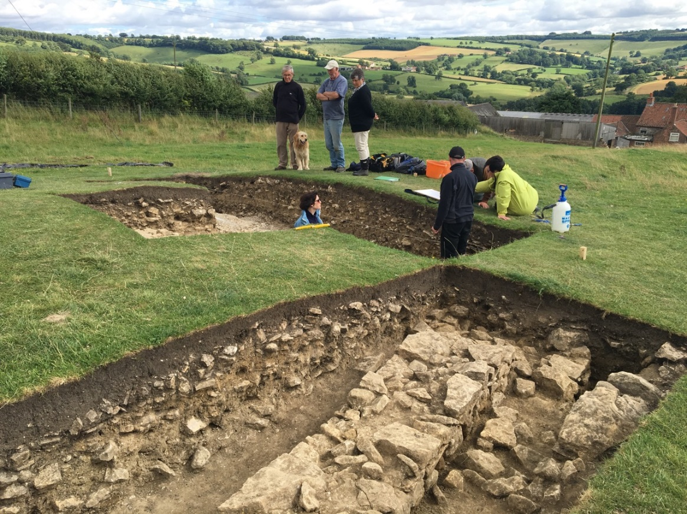
© Trevor Pearson
COUNCIL FOR BRITISH ARCHAEOLOGY
YORKSHIRE GROUP
AFFILIATE MEMBERSHIP
Registered Charity No. 519581
www.cba-yorkshire.org.uk
membership@cba-yorkshire.org.uk
OUR PAST FOR THE FUTURE
Every part of Yorkshire has a story to tell that is woven into our soils, landscapes and buildings. This historic environment is one of our richest resources and gives a special quality to our lives. It is also irreplaceable. Yet because we live and work in it, it is easily overlooked or squandered.
Nothing stays the same. Change made the past, just as it will shape the future. But we owe it to those who follow us to find ways of managing change so that they will have a past for themselves.
That is why CBA Yorkshire exists: to give a voice to Yorkshire’s past and to help enrich its future.
THE CBA YORKSHIRE REGIONAL GROUP
- is a network of individuals and organisations with an interest in Yorkshire’s past
- provides a link between local archaeology, history and heritage societies and groups in Yorkshire and between professional archaeologists and enthusiasts
- is an independent voice of archaeology in Yorkshire.
THE CBA YORKSHIRE REGIONAL GROUP WORKS TO
- advance the study and care of Yorkshire’s historic environment
- improve public knowledge of, and provide information about, Yorkshire’s past
- encourage widespread participation in archaeology throughout society
OUR AIMS
- to bring together those interested in the archaeology of Yorkshire
- to campaign to raise awareness of Yorkshire’s heritage
- to promote archaeology in education
- to encourage participation in archaeology
- to provide information on archaeological matters
- to support local, regional and national heritage societies
- to work with other partners in conserving the historic environment
BY JOINING THE CBA YORKSHIRE REGIONAL GROUP YOU CAN
- help us develop our work in education and conservation
- raise the profile of archaeology in the minds of decision makers
- be part of an organisation that really cares about Yorkshire’s special heritage
GRANTS
A biannual grant of £200 is awarded at alternate AGMs through the King and Thubron Memorial Award schemes. This is open to any archaeological project undertaken in Yorkshire by amateur or student groups or individuals. From time to time, depending on available funding, additional grants may be made for other worthwhile projects at the discretion of the Trustees.
BENEFITS OF MEMBERSHIP
- You will receive an annual publication, FORUM, containing abstracts of articles on recent archaeological work in Yorkshire. This is normally published in February each year and is complemented by exclusive access to members for the full articles in e-book format
- You will get at least four e-newsletters each year that highlight our own activities and those of our institutional members
- You will be able to send a delegate to our committee meetings and contribute to the running of the group
- You will get reduced price entry for one delegate to the annual symposium in February, where members report on their archaeological work
- You will get reduced price entry for one delegate to our annual Autumn Showcase event
- You will have the opportunity to attend a variety of other meetings, day-schools and events during the year
- You will have the opportunity of becoming involved in the development of archaeology in Yorkshire
- You will support our advocacy work.
NATIONAL MEMBERSHIP
National membership of the Council for British Archaeology is available to institutions. It is separate from membership of CBA Yorkshire but CBA Yorkshire membership can be added to national membership.
Full details can be found at
http://new.archaeologyuk.org/become-a-cba-member
or by phoning 01904 671 417
or by writing to The Council for British Archaeology, 92Micklegate, York, YO1 6JX

